**Question 3:** The output shown below is from python code **Assignment1_Question3.py**

**PART A.**

* The empirical fraud rate is approximately **0.1042**, which means approximately **10.42%** of investigations are found to be frauds.



**PART B.**

* In the Training Partition, there are **4768 observations**.
* In the Testing Partition, there are **1192 observations**.

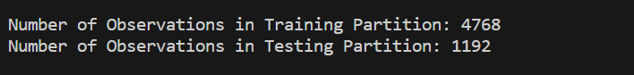

**PART C.**

* Misclassification Rates for Different Numbers of Neighbors in the Testing Partition:

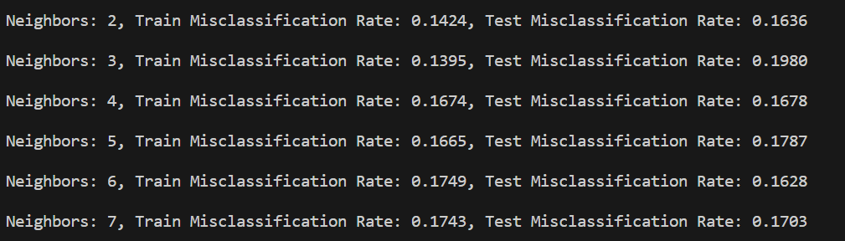

**PART D.**

* The number of neighbors that yields the lowest misclassification rate in the Testing Partition is **6.**

**PART E.**

* Neighbor Observation Values:

